ELP725
Wireless Communication Lab

Experiment No. : 8
Using GNURadio Companion to build
QPSK Modem on SDR04



0

Indian Institute of Technology , Delhi

Submitted By :
Group No – 8
Anshuman Singh (2018JTM2004)
Date : 14th March 2019

Objectives :

- To build a digital baseband modem that can use Quadrature Phase Shift Keying (QPSK)
- To introduce the basic concepts of modulation and demodulation.

Equipment Required :

- 2 AMITEC SDR04 Hardware
- Log-periodic dipole and omni-directional dipole antenna
- 2 Computers with GNU Companion Radio installed

Observations :

1. Transmission and Reception (Without Antennas):

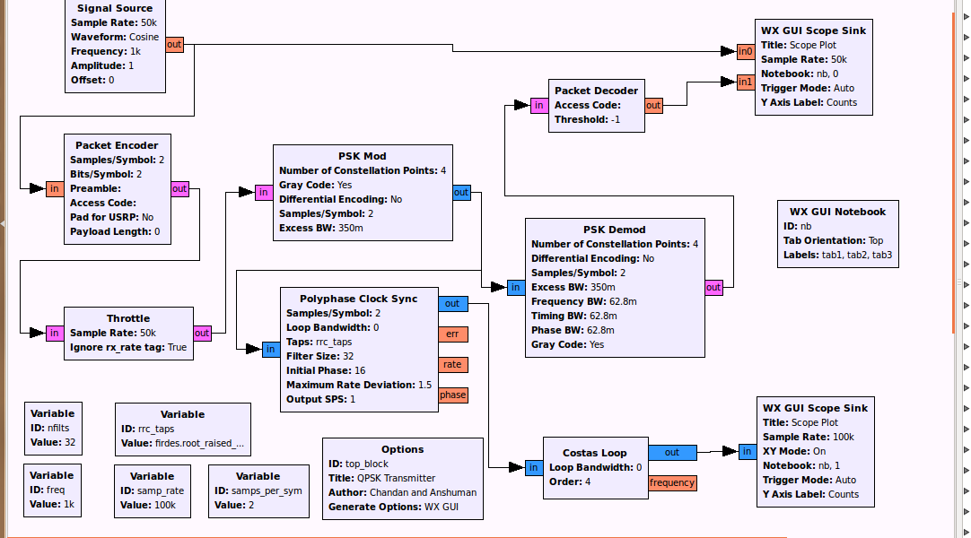

Figure 1: QPSK Simulation flowgraph
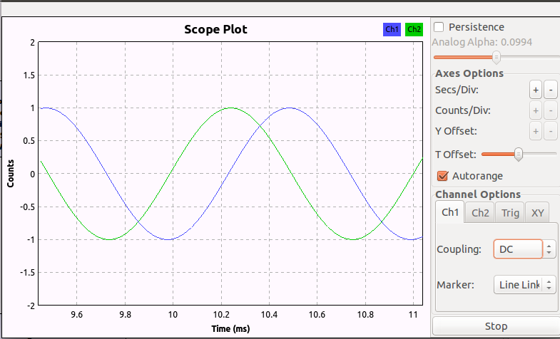
Figure 2: QPSK Input and Output signals

Figure 3: QPSK Constellation plot with Loop Bandwidth = 0.01
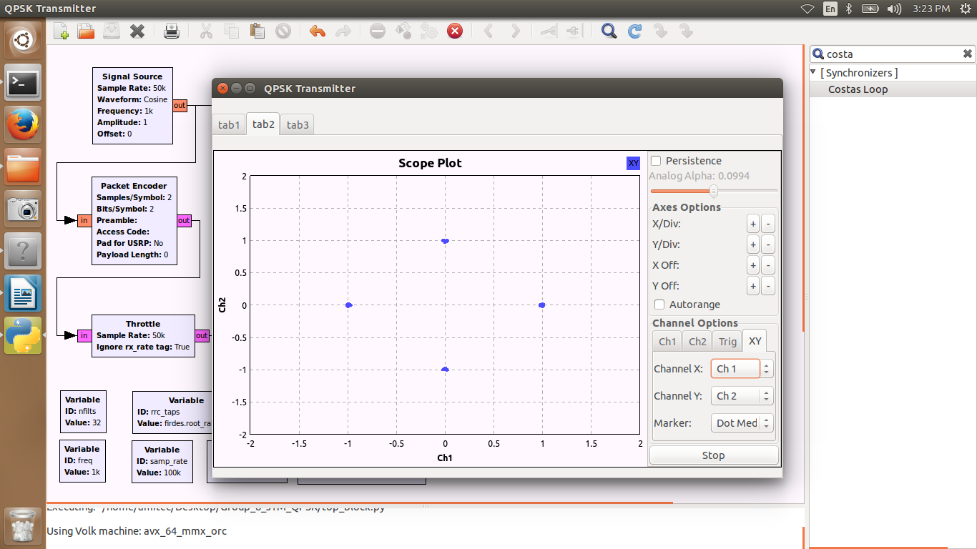

Figure 4: QPSK Constellation plot with Loop Bandwidth = 0
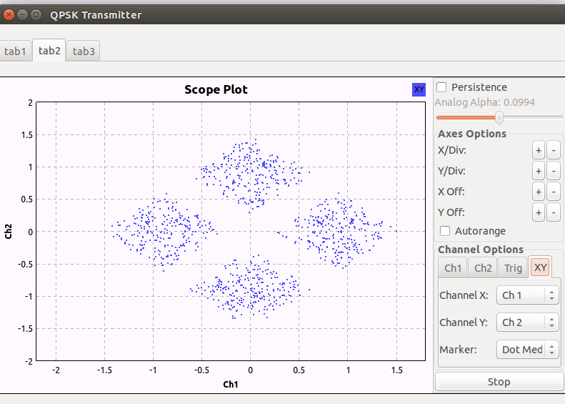

2. Transmission & Reception (with Antenna):

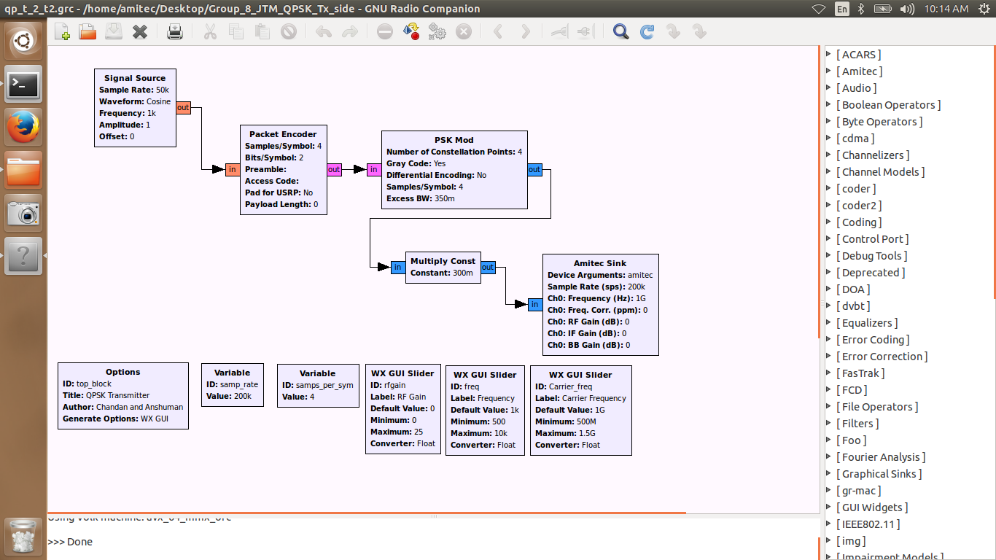

Figure 5: QPSK Modulator Flowgraph

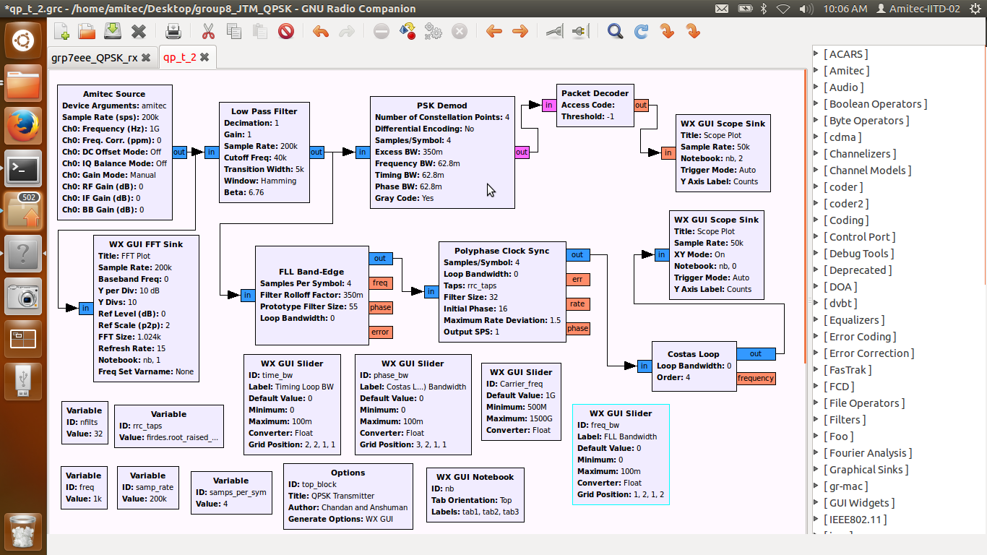
Figure 6: QPSK Demodulator Flowgraph

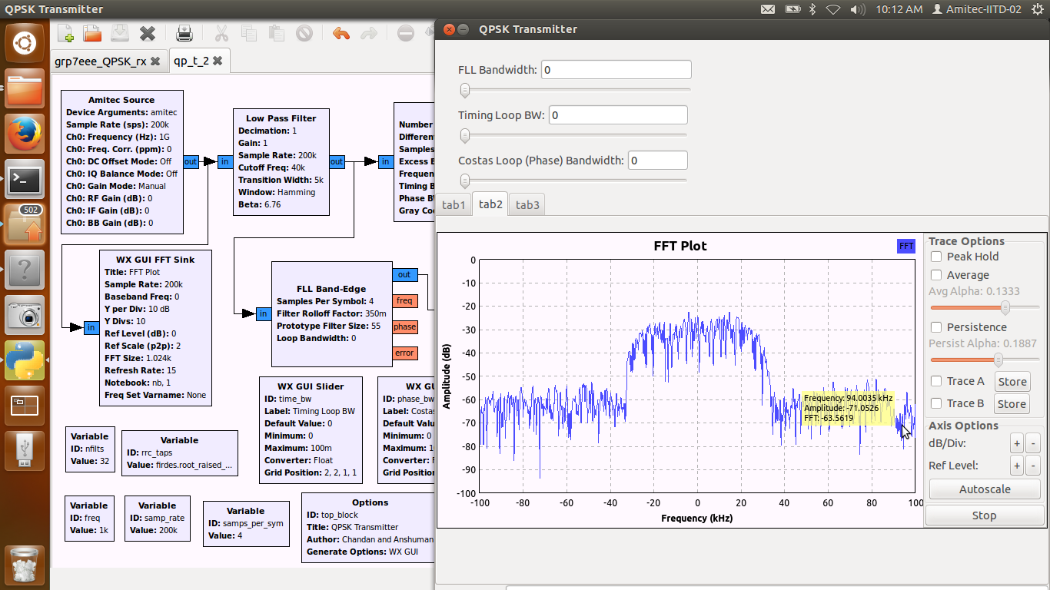

Figure 7: FFT Flowgraph

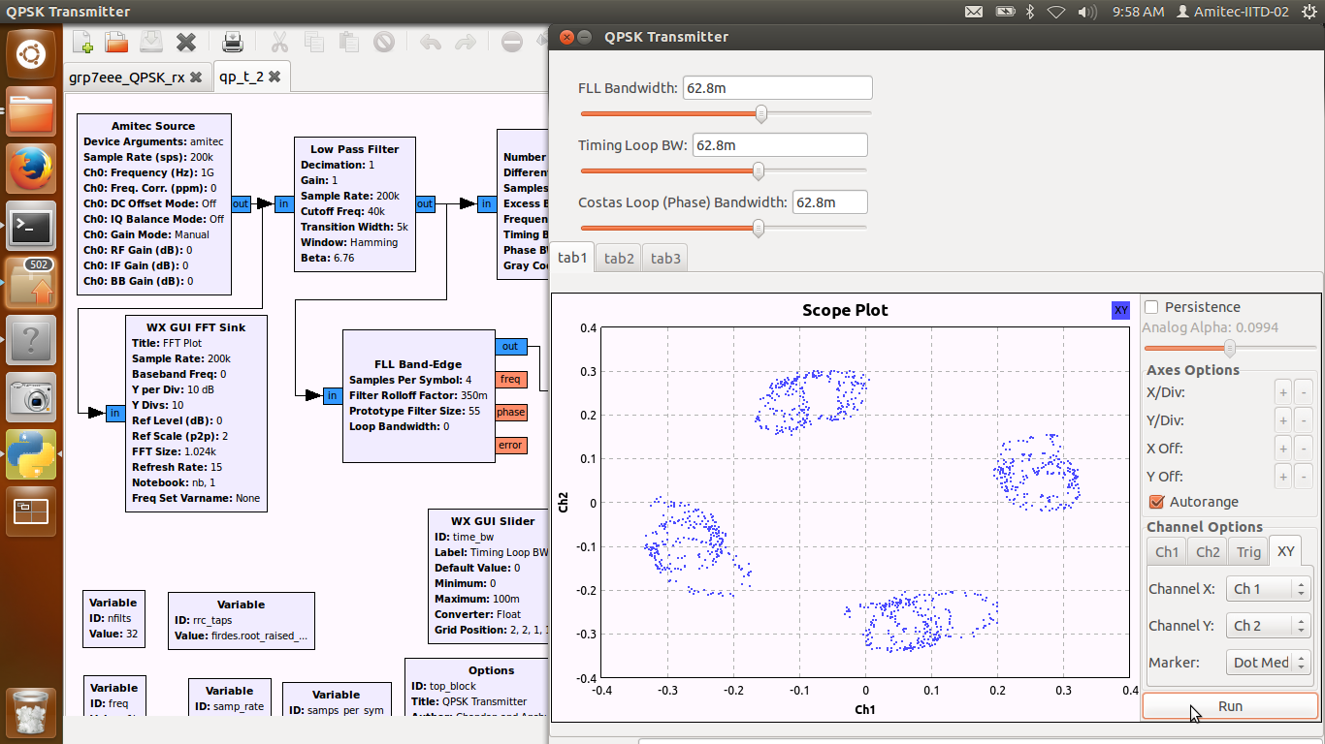
figure 8: QPSK Contellation plot

Analysis :
- In QPSK scheme, 1KHz modulating signal and 1GHz carrier signals are used along with RF gain slider at the transmitter side.
- All the signals before transmission are observed with the help of single amitec sink block.
- The received signal is passed through low pass filter with cutoff frequency of 50KHz.
- After the signal passes through the filter, it is passed through FLL BandEdge, polyphase clock sync and costas loop blocks.
- Finally the received signal is observed in two individual scope sink blocks.

Conclusion :

- The signal reception accurately depends on the filter frequencies used and directionality of the antennas used.
- The schemes are validated with the help of scope and FFT plots.

